Ctd order Rt no. 60
Telephone No. 0866 2455614
Fax: 0866 2452102
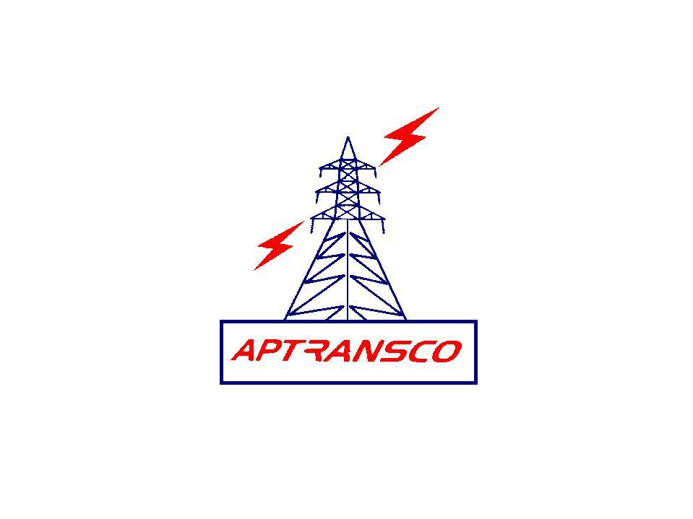

TRANSMISSION CORPORATION OF ANDHRA PRADESH LIMITED

(An ISO 9001: 2008 Certified Company)

LOCAL PURCHASE ORDER IN DUPLICATE

From To
The Chief Engineer, M/s. JVS Electronics Pvt. Ltd.,
Zone, A.P.TRANSCO #121, Manchanayakanahalli,
Gunadala, Bangalore Mysore Highway,
Vijayawada Bidadi Hobli, Ramanagara Dist.
Karnataka – 562109.

LPO.No.CE/Zone/VJA/Tech/AE /LPO.No. 27/13-14/D.No. 1112/13, dt. 16-11-13

Dear Sir,
Sub:- A.P.TRANSCO- Zone, Vijayawada- Procurement of JVS make relay to capacitor bank – I at 132KV substation, Y. G Palem - Detailed purchase order - Issued-Reg.

Ref:- Quotation Ref of 130510, dt. 25.09.2013
* * *
I, acting for and on behalf of Transmission Corporation of Andhra Pradesh Limited (herein after called the A.P.TRANSCO) accept your offer dt. 25.09.2013 cited in the above reference for procurement of JVS make relay to capacitor bank-I at 132KV substation, Y. G Palem of the above cited correspondence and subject to the terms and conditions setout in the order.
- SCOPE OF SUPPLY: This contract relates to the supply of materials as detailed in clause.2 below.
- SCHEDULE OF MATERIAL AND PRICES:
Sl. No. | Description | Qty | Rate  Rs Ps | Unit | Amount  Rs Ps
01 | JVS make, software based, programmable, non-directional, inverse time, 4 pole (3 O/C + 1 E/F) with out instantaneous highest elements, type JRC 054: rates current – 1A; aux. supply – 175 to 300V DC; the relay to be supplied in standard 144 mm sq. draw out type case having a depth of 232 mm, and suitable for flush mounting: panel cutout dimension 138 x 138 (WxH) mm. | 1 No. | 13200.00 | Each | 13200.00
 | SUB- TOTAL-I |  |  |  | 13200.00
 | Excise duty @ 12.36% on Sub-Total-I |  |  |  | 1631.52
 | SUB- TOTAL-II |  |  |  | 14831.52
 | CST @ 2% on Sub-Total-II |  |  |  | 296.63
 | Freight |  |  |  | 500.00
 | TOTAL |  |  |  | 15628.15
(Rupees Fifteen thousand six hundred twenty eight and paise fifteen only)

- PRICES: The prices indicated in clause.2 above are firm and for delivery F.O.R TLC stores, Ongole and are not subject to any variation on any grounds. The prices are inclusive of standard packing and forwarding, transit insurance charges and Excise duty, CST and freight as mentioned in clause No 2.

- TRANSIT INSURANCE: The materials shall be duly insured by you. You are responsible for settlement of insurance claims and replacement of lost / damaged / short supplied materials.

- SALES TAX: C.S.T @2% against ‘C’ form included in clause 2. The A.P.TRANSCO ‘C’ form registration No. is PJY/07/01/1840 /99-2000.

- EXCISE DUTY: The prices included in clause No.2. Present rate of excise duty 12.36%.
You shall furnish the following certificate with the invoice.
‘Certified that the Excise duty claimed in the invoice is adjusted in the personal ledger account maintained by the Central Excise Department on “. You shall also agree that if at any time, any central excise duty reported to have been paid by you, has not been paid or a lesser amount has been paid by you shall refund such amounts irrespective of time. Any benefit due to MODAVT scheme shall be passed on the A.P.TRANSCO.

- DELIVERY: The proforma invoice shall be submitted with in one week from the date of receipt of this purchase order and the materials described in clause No.2 shall
be dispatched within 3 weeks from the date of confirmation of readiness of cheque
from the Superintending Engineer/ TL&SS/ Nellore.

Any variation up or down in sales tax or other statutory levies or new levies introduced by the Government after placing of this purchase order shall be to A.P.TRANSCO’s account.

Provided that in cases where the delivery schedule is not adhered to by you and there are increases in excise duty or sales tax or other statutory levies of new imposts after the agreed delivery dates, you shall bear the impact of these levies and if there is downward variations/ revision the A.P.TRANSCO shall be given credit to that extent.

You are also requested to dispatch the materials only on receipt of confirmation of readiness of cheque from the Superintending Engineer/TL&SS/ Nellore.

- PENALTY: In case of delay in delivery of materials, whatever may be the reason, penalty at the rate of ½% per week or part thereof subject to a maximum of 5% of the purchase order value will be levied.

- TERMS OF PAYMENT:
100% payment will be made against proforma invoice. The proforma invoice in triplicate may be submitted immediately to the Superintending Engineer/TL&SS/ Nellore on receipt of purchase order. The material may be dispatched after hearing the confirmation readiness of cheque from the Superintending Engineer/TL&SS/ Nellore Also actual dispatch details may be intimated to the Superintending Engineer/ TL&SS/ Nellore for taking steps to release the consignment in time and for arranging insurance.

- DESPATCH INSTRUCTIONS: The materials as per clause No. (2) Shall be consigned to the Asst. Executive Engineer/ TLC/ SD-I/ Ongole and dispatched by Road to the consignee, as indicated in clause No. (3).

All original documents shall be sent to the Superintending Engineer/TL&SS/ Nellore for arranging payment. Copies of invoices shall be marked to the Superintending Engineer/TLC/Vijayawada

A Photostat copy of the L.R shall be sent one each to the Superintending Engineer/ TL&SS/ Nellore, and Asst. Executive Engineer/ TLC/ SD-I/ Ongole immediately after dispatched through any reputed transporting contractors.

- PERFORMANCE GUARANTEE: The spares/ equipment offered by you are guaranteed against manufacturing defects, for materials quality and workmanship, for proper fitment to the original equipment and for satisfactory performance for a period of 12 months from the date of putting them into service or 18 months from the date of dispatch whichever is earlier. You shall be liable to make good any defects that may develop in the materials/ spares due to faulty designs, unsound materials or bad workmanship provided always that such defective parts are not repairable at site and are not in the mean time essential in commercial use of the sub-station / lines are promptly returned to your works unless otherwise arranged.

- PACKING: All the materials shall be securely packed in such a manner as to withstand rough handling during transport up to site. All the above materials shall be adequately protected before dispatch to prevent damage, corrosion and entrance of foreign matter.

- LOSS OR DAMAGE: External damages or shortages that are prima facia, the result of rough handling in transit or due to defective packing will be intimated to you within a fortnight of receipt of the materials. Internal defects/ damages or shortages of any internal parts which can not ordinarily be detected on a superficial visual examination though due to bad handling in transit or defective packing or other reasons would be intimated within two months from the date of receipt of materials. In either case, the defective or damaged materials shall be replaced and shortages made good by you, free of cost to the A.P.TRANSCO.

- CORRESPONDENCE:
  - Your acknowledgement of receipt of this order and all correspondence of general or technical nature shall be addressed to this office.
  - All correspondence regarding dispatch, payments etc., shall be addressed to the Superintending Engineer/ TL&SS/ Nellore with copies marked to this office.

- JURISDICTION: All and any disputes or differences arising out of or touching this orders shall be decided by courts or tribunals situated in Vijayawada. No suit or other legal proceedings shall be instituted elsewhere.

- ACKNOWLEDGEMENT: Please acknowledge the receipt of this order with your confirmation of its acceptance. The additional copy enclosed may please be returned with your signature in token of your acceptance.

Yours faithfully

CHIEF ENGINEER
APTRANSCO
VIJAYAWADA ZONE

We accept the terms and conditions of this order.
SIGNATURE OF THE SUPPLIER

Copy transmitted to the Chief Engineer/ Transmission/ Vidyut Soudha/ Hyderabad

Copy to: -
The Superintending Engineer/TL&SS/ Nellore
The Executive Engineer/ TLC/ Ongole.
The Divisional Engineer/ TL&SS/ Ongole

The ADE/O&M, O/o Chief Engineer/Zone/Vijayawada

/tmp/in/input.doc

